Title: How to connect Windows 10 client to L2TP VPN network

External [X] Internal Only [ ]

Applicable Product(s), Firmware(s): FortiOS 6.0 branch and Windows 10

Solution:

FortiGate configuration:

Navigate to GUI: “Users & Device” - “User Groups” and hit “Create New” button.

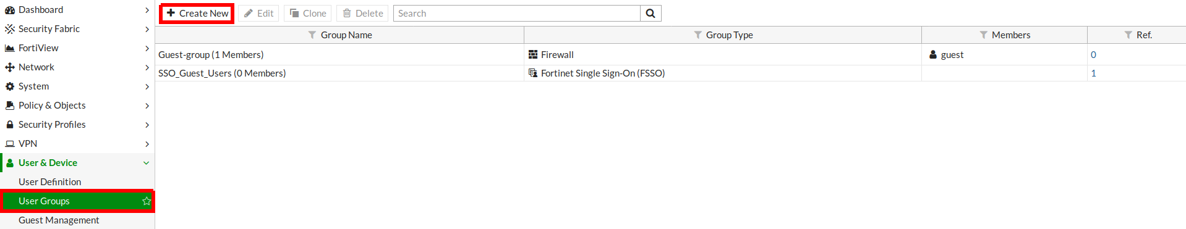
Set “Name” and select “Type”, after that hit “OK” button.

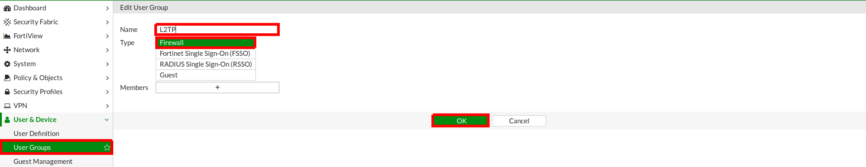
Navigate to GUI: “Users & Device” - “User Defenition” and hit “Create New” button.

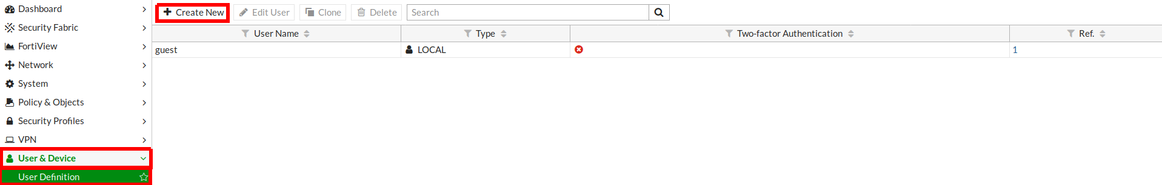
Select “User Type”

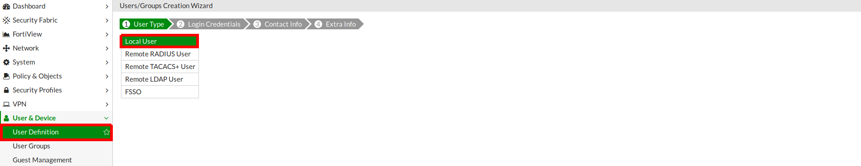
Enter “Username” and “Password”

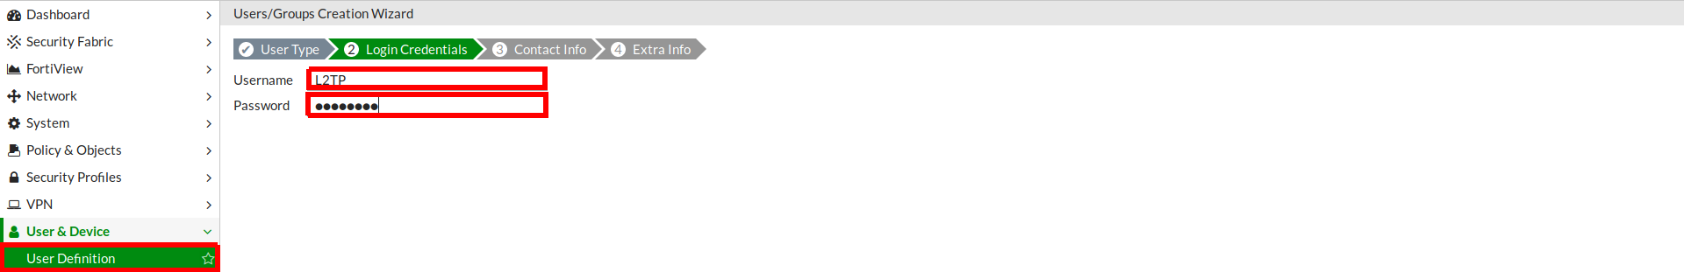
Enter “Email Address”

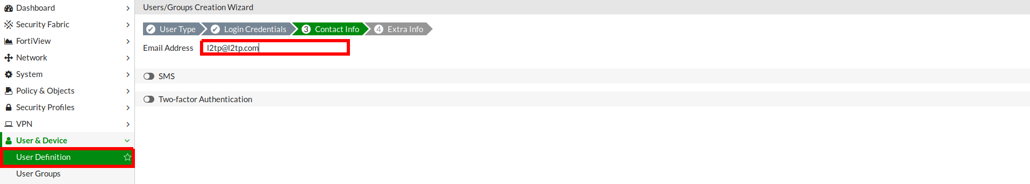
Select “User Account Status” and “User Group”

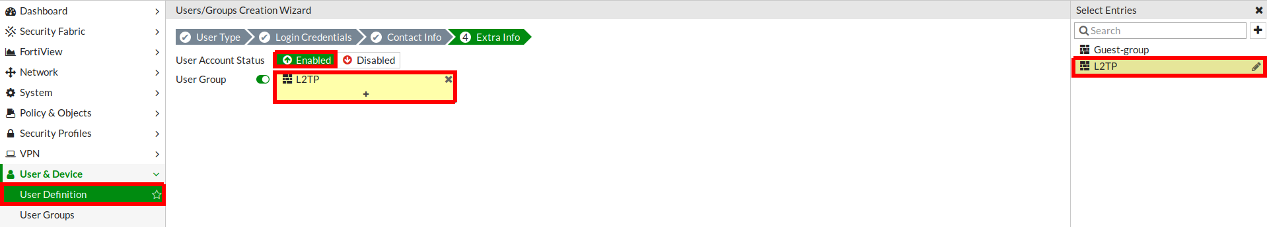
Navigate to GUI: “VPN” - “IPsec Wizard”. Fill in “Name” field, select “Template Type”, “Remote Device Type” and hit “Next” button.

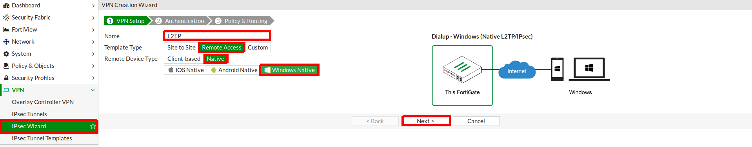
Select physical “Incoming Interface”, select “Authentication Method”, “Pre-shared Key”, “User Group” and hit “Next” button.

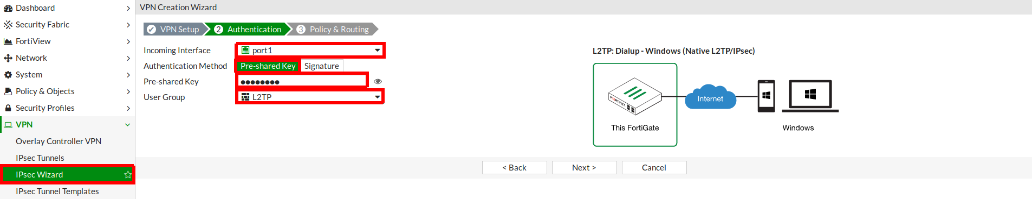
Select “Local Interface”, “Local Address”, fill in “Client Address Range” and “Subnet Mask” fields and then hit “Create” button.

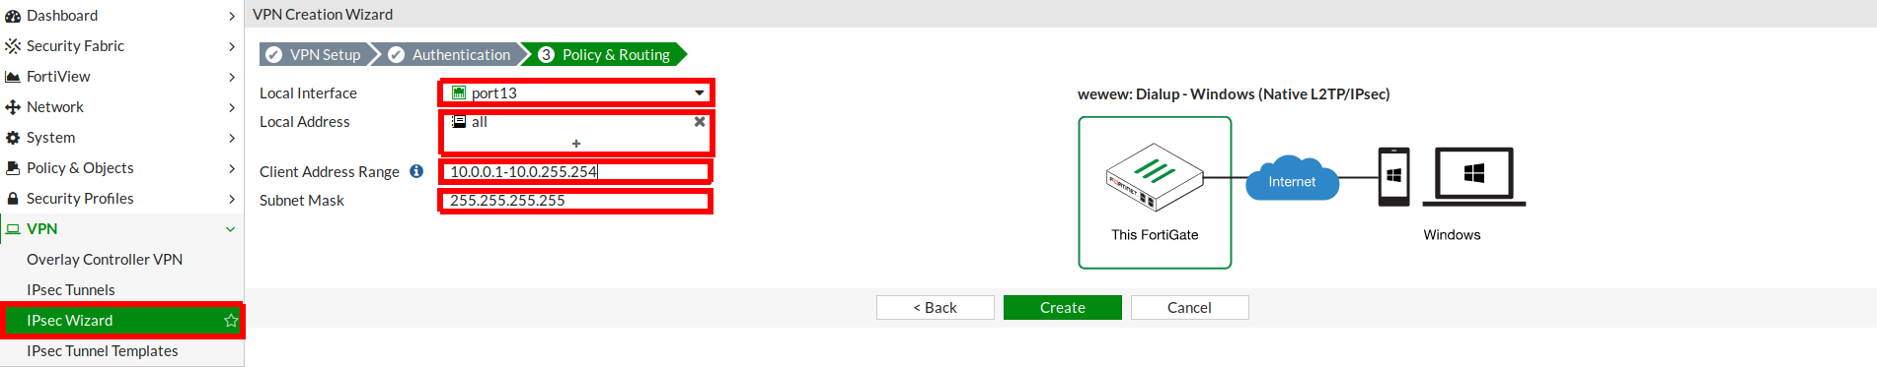
Windows configuration:

Navigate to Windows settings



Select “VPN” and then hit “Add a VPN connection” button

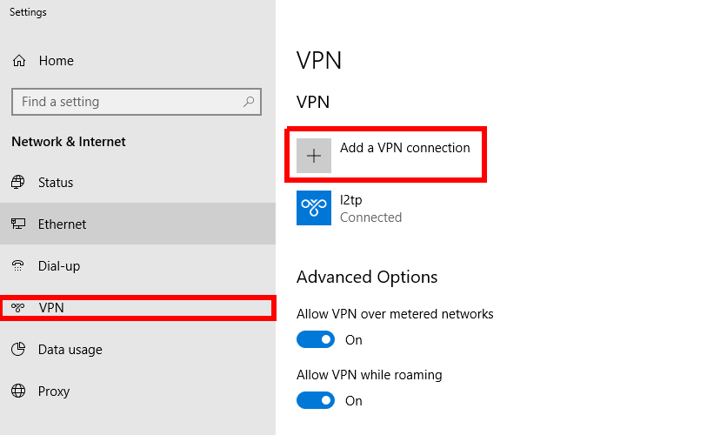
Fill in all necessary fields and hit “Save” button

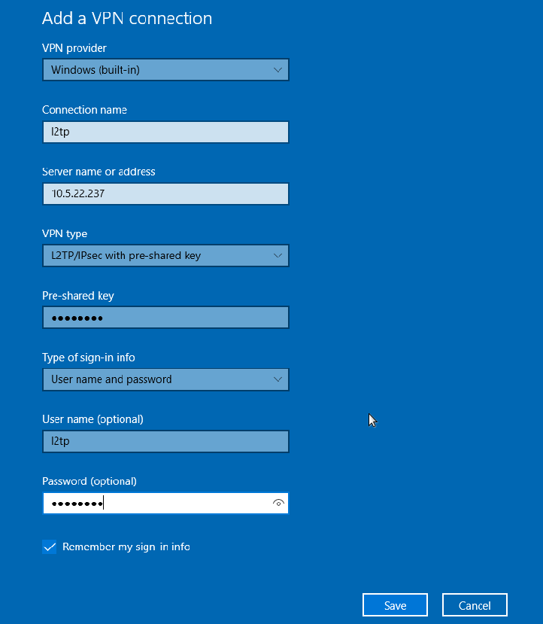

After that connect to L2TP VPN network

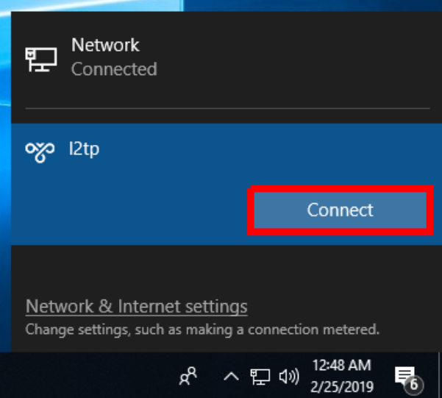

Connection is established successfully!

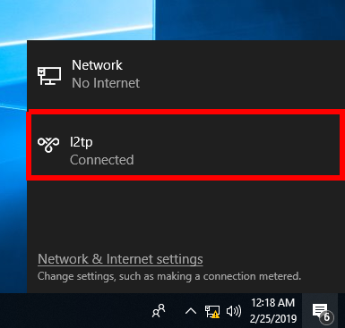

Related KB articles/BUGs (optional)
https://kb.fortinet.com/kb/documentLink.do?externalID=FD35361
https://kb.fortinet.com/kb/documentLink.do?externalID=FD35361
https://kb.fortinet.com/kb/documentLink.do?externalID=100117
https://kb.fortinet.com/kb/viewContent.do?externalId=FD32300
https://kb.fortinet.com/kb/viewContent.do?externalId=FD33189

