This article explains how to access the individual slots with the same external management IP using the special port number.

Configure an External management IP under Load Balance > Config
GUI:
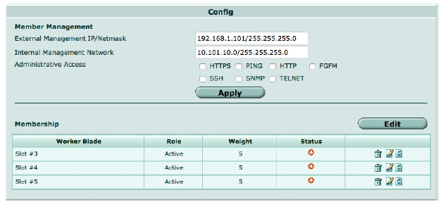
CLI:
config load-balance setting
set base-mgmt-external-ip 192.168.1.101 255.255.255.0
set base-mgmt-allowaccess https ssh ping
end

You can use the external management IP followed by a special port number to manage individual devices in the cluster. The special port number identifies the protocol and the chassis and slot number of the device you want to connect to. In fact this is the only way to manage the backup FortiControllers. The special port number begins with the standard port number for the protocol you are using and is followed by two digits that identify the chassis number and slot number. The port number is determined using the following formula:
service_port x 100 + (chassis_id - 1) x 20 + slot_id

Some examples:
HTTPS, chassis 1 slot 2: 443 x 100 + (1 - 1) x 20 + 2 = 44300 + 0 + 2 = 44302, browse to:
https://192.168.1.101:44302

HTTPS, chassis 2, slot 10: 443 x 100 + (2 - 1) x 20 + 10 = 44300 + 20 + 10 = 44330, browse to:
https://192.168.1.101:44330

Below chart can be a reference for the special ports used for management access of all the slots of both Chassis-1 and Chassis-2:
