Versions 5.6, 6.0 and 6.2
How to route specific traffic to one member of the SD-WAN
Description
This article shows an example on how to route traffic from specific source to one member of the SD-WAN.

Scope
FortiGate/FortiOS 5.6.0, FortiOS 6.0.x and FortiOs 6.2.x
Configuration example
In this configuration example we will route traffic coming from “subnet” to port1, only in case of link or interface failure
the traffic from “subnet” will be routed to port2
- Create address object
config firewall address
edit subnet
set subnet 192.168.1.1 255.255.255.0
next
- Configure SD-WAN members
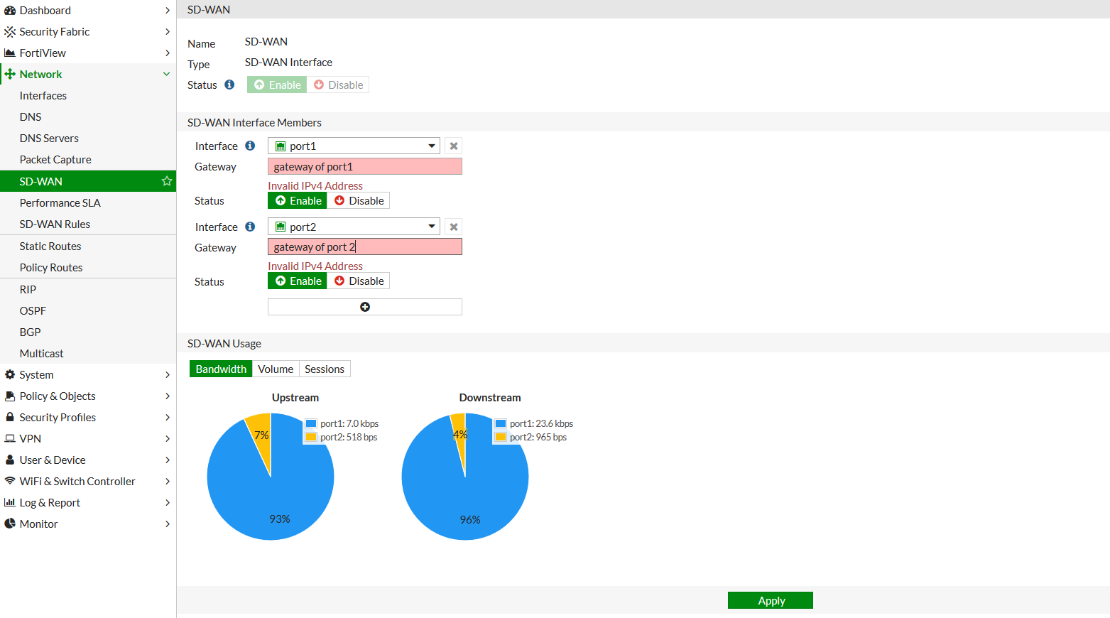

- Configure Performance SLA
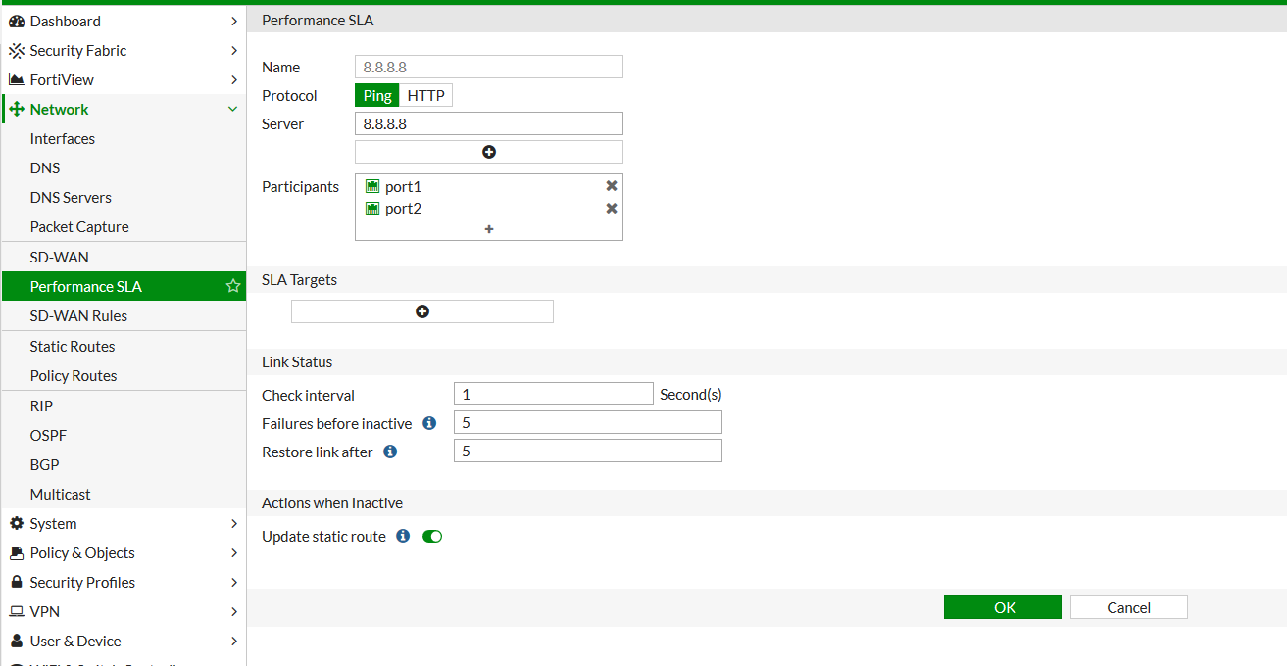
- Configure SD-WAN rule on CLI with mode manual including only the preferable member
config system virtual-wan-link
config service
edit 1
set name subnet-to-port1
set mode manual
set member 1
set dst all
set src subnet
end

the config should be as below:
config system virtual-wan-link
set status enable
config members
edit 1
set interface "port1"
set gateway 10.1.1.2
next
edit 2
set interface "port2"
set gateway 20.2.2.2
next
end
config health-check
edit "8.8.8.8"
set server "8.8.8.8"
set members 1 2
next
end
config service
edit 1
set name "subnet-to-port1"
set member 1
set dst "all"
set src "subnet"
next
end
end

- Generate traffic from “subnet” to verify that it is using the correct interface
To verify run a sniffer to capture the traffic coming from “subnet”
4.979750 port1 out 10.1.1.1 -> 8.8.4.4: icmp: echo request
4.981440 port1 in 8.8.4.4 -> 10.1.1.1: icmp: echo reply
4.981444 mgmt out 8.8.4.4 -> 192.168.1.1: icmp: echo reply
5.996049 mgmt in 192.168.1.1 -> 8.8.4.4: icmp: echo request
5.996053 port1 out 10.1.1.1 -> 8.8.4.4: icmp: echo request
5.997690 port1 in 8.8.4.4 -> 10.1.1.1: icmp: echo reply
5.997692 mgmt out 8.8.4.4 -> 192.168.1.1: icmp: echo reply
7.027688 mgmt in 192.168.1.1 -> 8.8.4.4: icmp: echo request

In case the link will fail the SD-WAN rule will be ignored and the traffic will be routed to port2
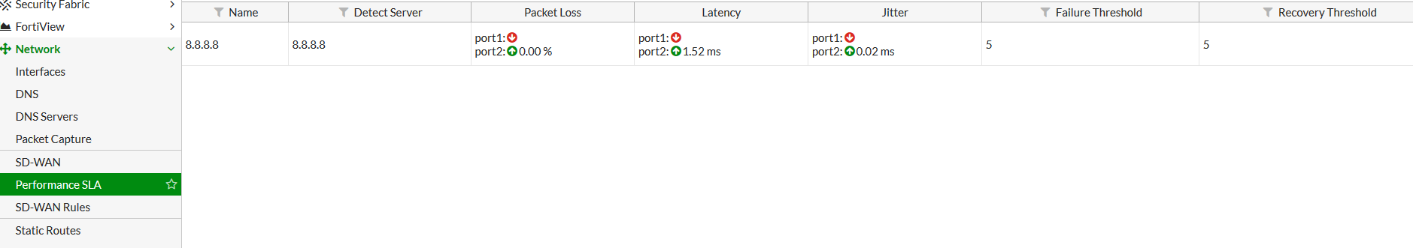
To verify run a sniffer to capture the traffic coming from “subnet”
3.368375 port2 out 20.2.2.1 -> 8.8.4.4: icmp: echo request
203.370026 port2 in 8.8.4.4 -> 20.2.2.1: icmp: echo reply
203.370029 mgmt out 8.8.4.4 -> 192.168.1.1: icmp: echo reply
204.384004 mgmt in 192.168.1.1 -> 8.8.4.4: icmp: echo request
204.384006 port2 out 20.2.2.1 -> 8.8.4.4: icmp: echo request
204.385619 port2 in 8.8.4.4 -> 20.2.2.1: icmp: echo reply
204.385622 mgmt out 8.8.4.4 -> 192.168.1.1: icmp: echo reply
205.400076 mgmt in 192.168.1.1-> 8.8.4.4: icmp: echo request

Notes:
This configuration example is focusing on how to create the SD-WAN rule and the Performance SLA in order
not to load balance specific traffic.
To configure the SD-Wan service you should follow the information on below doc:
https://docs.fortinet.com/document/fortigate/6.0.0/cookbook/990932/redundant-internet-with-sd-wan

