Title | Where to download FortiManager (FortiAnalyzer) and FortiCore MIB files
External [X] Internal Only []
Applicable Product(s): | FortiManager  FortiAnalyzer
Firmware(s): | FortiManager (FortiAnalyzer) 5.0,5.2, 5.4, 5.6, 6.0
Purpose/Description | This article shows where to download FortiManager (FortiAnalyzer) and FortiCore MIB files from Support Site.
Solution | Since version 5.0, FortiManager and FortiAnalyzer codes have been merged since they were sharing similar features.  As consequence, FortiManager and FortiAnalyzer share same MIB database file (FORTINET-FORTIMANAGER-FORTIANALYZER-MIB.mib).  As all main Fortinet products, FortiManager and FortiAnalyzer require to use the common CORE MIB (FORTINET-CORE-MIB.mib)  The FortiManager (FortiAnalyzer) and FortiCore MIB files can be downloaded from the Fortinet Support Web Site.  NOTE: differently by FortiGate, is not possible to download it from GUI.  Download MIBs from Fortinet Support Web Site  - Log-in the Support portal with username and password https://support.fortinet.com/  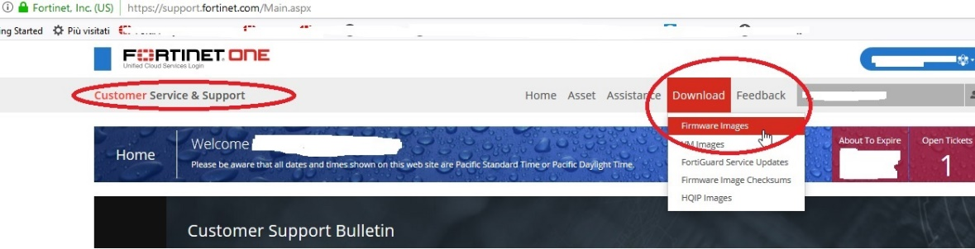  - On the Customer Service Support page, click on Download > Firmware Images (https://support.fortinet.com/Download/FirmwareImages.aspx):  - Then select Product > FortiManager and then click on 'Download' tab.  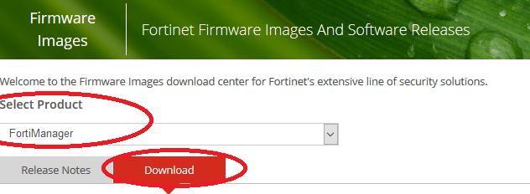  - Select the appropriate FortiManager Version directory (5.00, 6.00).  - Select the MIBS directory and download the applicable files using the https link (see below):  - go to “v6.00” > “6.0” > “6.0.4” > “MIB” and https download file FORTINET-FORTIMANAGER-FORTIANALYZER-MIB-build0292.mib'.  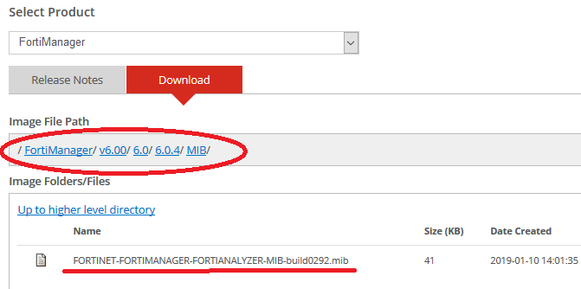  - For FORTINET-CORE-MIB.mib you have go to version 5.00 (see below):  - go to “v5.00” > “Core MIB” and https download file FORTINET-CORE-MIB.mib.  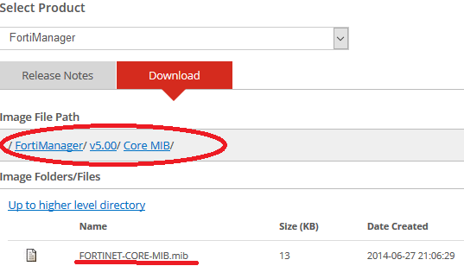
Internal Notes (optional)
Related KB articles/BUGs (optional) | FD30891, FD34731, 11607
Attachments (config files, pcap files, etc)

